**Solutions for Dash App Interactivity Assignment**

**Exercise A:** Incorporate the [2011_us_ag_exports.csv](https://github.com/plotly/datasets/blob/master/Dash-Course/US-Exports/2011_us_ag_exports.csv) dataset into your app. And create the following layout in one app file:

1. A [Dropdown](https://dash.plotly.com/dash-core-components/dropdown) that uses column state as the dropdown options. Then, assign “Alabama” as the initial value. The dropdown id should equal “state-dropdown”.

This is the result that you should see:

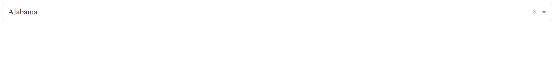

*from* dash *import* Dash, dcc, html

*import* pandas *as* pd

*import* plotly.express *as* px

df = pd.read_csv('https://raw.githubusercontent.com/plotly/datasets/master/Dash-Course/US-Exports/2011_us_ag_exports.csv')

app = Dash(__name__)

app.layout = html.Div([

dcc.Dropdown(id="state-dropdown", options=df.state.unique(), value="Alabama")

])

*if* __name__ == '__main__':

app.run(debug=*True*)



2. Above the dropdown, add an html.Div, and assign to the id property the string “my-title”. Add your own title to the children property of the html.Div. Below the dropdown, add an empty dcc.Graph. The id of the graph component should be “graph1”.

This is the result that you should see:

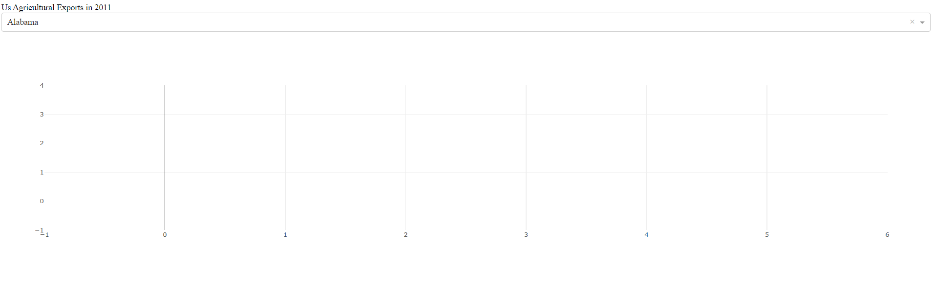

Solution 1:

*from* dash *import* Dash, dcc, html

*import* pandas *as* pd

*import* plotly.express *as* px

df = pd.read_csv('https://raw.githubusercontent.com/plotly/datasets/master/Dash-Course/US-Exports/2011_us_ag_exports.csv')

app = Dash(__name__)

app.layout = html.Div([

html.Div(id="my-title", children="Us Agricultural Exports in 2011"),

dcc.Dropdown(id="state-dropdown", options=df.state.unique(), value="Alabama"),

dcc.Graph(id="graph1")

])

*if* __name__ == '__main__':

app.run(debug=*True*)



**Exercise B:** Add a [callback](https://dash.plotly.com/tutorial#controls-and-callbacks) to your app.

1. Add a callback decorator that takes the value of the dcc.Dropdown as an Input argument and the figure of the dcc.Graph as an Output argument. Remember to import the Input and Output arguments at the very top.

Solution B1:

*from* dash *import* Dash, dcc, html, Input, Output

*import* pandas *as* pd

*import* plotly.express *as* px

df = pd.read_csv('https://raw.githubusercontent.com/plotly/datasets/master/Dash-Course/US-Exports/2011_us_ag_exports.csv')

app = Dash(__name__)

app.layout = html.Div([

html.Div(id="my-title", children="Us Agricultural Exports in 2011"),

dcc.Dropdown(id="state-dropdown", options=df.state.unique(), value="Alabama"),

dcc.Graph(id="graph1")

])

@app.callback(

Output(component_id='graph1', component_property='figure'),

Input(component_id='state-dropdown', component_property='value')

)

*if* __name__ == '__main__':

app.run(debug=*True*)



2. Add a callback function directly underneath the decorator. The function should take an argument called “state_selected”. Use pandas to filter the original dataframe (df) so that only rows with the “state_selected” remain in the new dataframe. Name the new dataframe “df_country”.

Create a [bar chart](https://plotly.com/python/bar-charts/#bar-charts-with-wide-format-data) with three arguments: the “df_country” assigned to the data_frame attribute; “state” assigned to the x-axis; and a list of three column names assigned to the y-axis. ['beef','pork','fruits fresh']

Return the bar chart at the end of the function. This is the app that you should see:

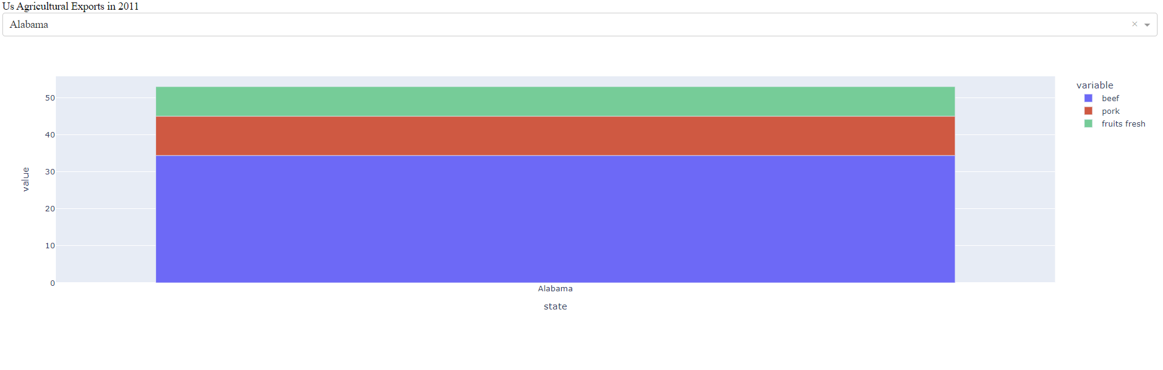

Solution B2:

*from dash import Dash, dcc, html, Input, Output*

*import pandas as pd*

*import plotly.express as px*

*df = pd.read_csv('https://raw.githubusercontent.com/plotly/datasets/master/Dash-Course/US-Exports/2011_us_ag_exports.csv')*

*app = Dash(__name__)*

*app.layout = html.Div([*

*html.Div(id="my-title", children="Us Agricultural Exports in 2011"),*

*dcc.Dropdown(id="state-dropdown", options=df.state.unique(), value="Alabama"),*

*dcc.Graph(id="graph1"),*

*])*

*@app.callback(*

*Output(component_id='graph1', component_property='figure'),*

*Input(component_id='state-dropdown', component_property='value')*

*)*

*def update_graph(state_selected):*

*df_country = df[df.state == state_selected]*

*fig1 = px.bar(data_frame=df_country, x='state', y=['beef','pork','fruits fresh'])*

*return fig1*

*if __name__ == '__main__':*

*app.run(debug=True)*



3. Let’s work with a [multi-value dropdown](https://dash.plotly.com/dash-core-components/dropdown#multi-value-dropdown). Use the multi property to allow your dropdown to accept multiple values. Update the value property by assigning it ["Alabama","Arkansas"]

Now that the dropdown value property is of type list, update the callback function: use pandas’ [isin method](https://pandas.pydata.org/pandas-docs/stable/reference/api/pandas.DataFrame.isin.html) on the state column to filter the dataframe according to the “states_selected”. The rest of the callback function can stay the same.

This is the app that you should see:

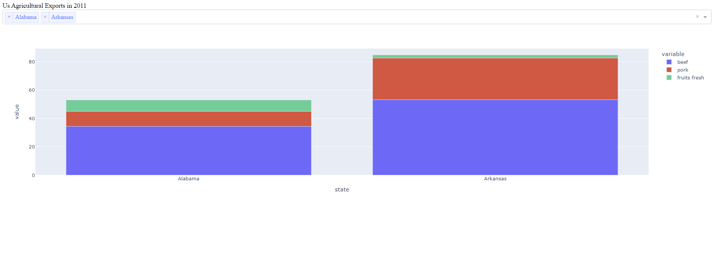

Solution B3:

*from dash import Dash, dcc, html, Input, Output*

*import pandas as pd*

*import plotly.express as px*

*df = pd.read_csv('https://raw.githubusercontent.com/plotly/datasets/master/Dash-Course/US-Exports/2011_us_ag_exports.csv')*

*app = Dash(__name__)*

*app.layout = html.Div([*

*html.Div(id="my-title", children="Us Agricultural Exports in 2011"),*

*dcc.Dropdown(id="state-dropdown", options=df.state.unique(), value=["Alabama","Arkansas"], multi=True),*

*dcc.Graph(id="graph1"),*

*])*

*@app.callback(*

*Output(component_id='graph1', component_property='figure'),*

*Input(component_id='state-dropdown', component_property='value')*

*)*

*def update_graph(states_selected):*

*df_country = df[df.state.isin(states_selected)]*

*fig1 = px.bar(data_frame=df_country, x='state', y=['beef','pork','fruits fresh'])*

*return fig1*

*if __name__ == '__main__':*

*app.run(debug=True)*



**Exercise C:** Choose your app project.

* We encourage you to think of an app that you would like to build by the end of this course. You can choose one of the two datasets ([agriculture](https://github.com/plotly/datasets/blob/master/Dash-Course/US-Exports/2011_us_ag_exports.csv), [makeup](https://github.com/plotly/datasets/blob/master/Dash-Course/makeup-shades/shades.csv)) provided in the course or your own dataset. When choosing a project, think of the following:
  + What data would I like to analyze? Is the data simple and clean?
  + What is the purpose of building this app?
  + What are you trying to facilitate or demonstrate with the app?
  + Why would you or others use your app?
* Post your thoughts on the forum if you want community feedback
* At the end of the course, when you’ve finished your Dash app, make sure to post the code and app images on the forum, under the dash-course tag
* A couple of participants will be selected to present their apps to Plotly staff members at the last session